DingDong UI/UX Evaluation report

LAB University of Applied Sciences
Bachelor of Engineering (Industrial Information Technology)
2026
Unubold Luvsandagva
Statement about using AI
The author of this thesis, Unubold Luvsandagva, is responsible for the accuracy of the entire contents including content generated with AI. AI was used in this work during background research and later for language editing.
 |  | Abstract
Author(s)  Unubold Luvsandagva | Publication type  UI/UX evaluation report | Completion year  2026
Number of pages
13
Title of the thesis
DingDong UI/UX Evaluation report
Degree, Field of Study
Industrial Information Technology
Name, title and organisation of the client
LAB University of Applied Science
Abstract
This report documents the application of five UI/UX evaluation and design methods drawn from the course material. Each method was selected for its suitability to the current stage of the project and applied directly to the DingDong interface. Findings, observations, and design implications are recorded for each method. The sixth method “5 seconds method” finding are already presented in class so not included in this report.

Keywords
UI/UX, method, interface, evaluation

Contents
1 Introduction 1
2 Applied Methods 2
2.1 Method 1: Comparative Analysis 2
2.1.1 Overview 2
2.1.2 Findings 2
2.1.3 Design decisions 3
2.2 Method 2. Moodboarding 3
2.2.1 Overview 3
2.2.2 Design decisions 4
2.3 Method 3. User Flows 5
2.3.1 Overview 5
2.3.2 Flow 1. New Worker Onboarding 5
2.3.3 Flow 2. New Employer Onboarding 6
2.3.4 End-to-End Job Lifecycle 7
2.3.5 Design decisions. 8
2.4 Method 4. Cognitive Walkthrough 9
2.4.1 Overview 9
2.4.2 Issue Identified 10
2.4.3 Design decisions 10
2.5 Method 5. Accessibility Testing 11
2.5.1 Overview 11
2.5.2 Finding A -- Light and dark mode toggle 11
2.5.3 Finding B -- Multilingual support (English, Finnish, Swedish) 11
2.5.4 Design decisions 12
3 Conclusion 13

- Introduction
DingDong is a web application designed to connect customers with local freelancers for short-term gig work. The platform features a dual-role architecture: users can register either as a Worker (looking for gigs) or as an Employer (looking to hire), and switch between these roles from within their account using a dedicated toggle.
The interface is built around two distinct visual themes — a deep blue palette for the Worker experience and a burnt orange/red palette for the Employer experience always ensuring immediate role clarity for users. The application supports three languages (English, Finnish, Swedish) and provides key screens including a landing/role selection page, authentication (sign in and sign up), a gig browsing dashboard, a portfolio/profile settings page, and a messaging view.

- Applied Methods
  - Method 1: Comparative Analysis
    - Overview
Comparative Analysis, also referred to as benchmarking, is a systematic method for examining existing products that address user needs like those of the project under development. Rather than copying competitors, the goal is to understand established conventions, recurring patterns, and the design trade-offs that shape user expectations in each category. (Theseus, 2025).
Focus areas
Three platforms were selected for comparison:
- Upwork -- a long-established global freelance platform, representative of mature, feature-rich UX patterns.
- Fiverr -- a marketplace-style platform with strong visual onboarding and dual-role functionality.
- TaskRabbit -- the closest analogue to DingDong, focused on local, short-term, often in-person work.
    - Findings
The dual-role unified account and the colour-coded split landing page were initially planned to a clear product need: a single user often needs to act in both worker and employer contexts. Comparative Analysis confirmed that this hypothesis was sound, since Fiverr's "Switch to Selling" model demonstrates that a single-account, dual-role pattern is viable and well-accepted by users. TaskRabbit's clear visual separation between roles further supported the colour-coding decision.
Two patterns were deliberately avoided. Upwork's heavy multi-step signup was rejected that allows users to reach the platform quickly. Fiverr's category-grid landing page was rejected in favour of a clean dual-pathway landing that asks the user a single, simple question ("Looking for a job?" vs. "Looking to hire?") and routes them accordingly.
    - Design decisions
- Have one unified account that can be used on both sides without requiring to create account on each side and need to log out and login every time.
- Made signup part shorter and user can set it up later or can just use browse as a guest option
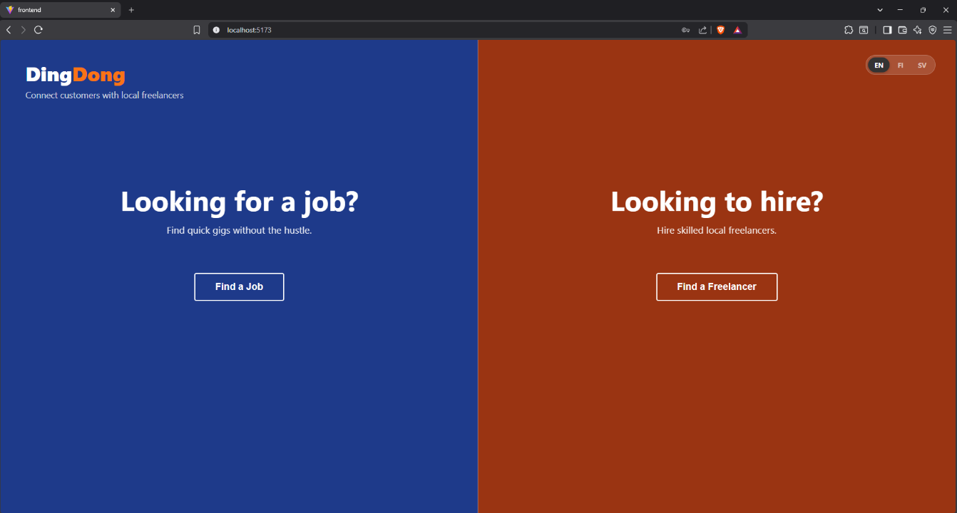

Image 1. Landing page
  - Method 2. Moodboarding
    - Overview
Moodboarding is a visual synthesis method used to define the intended emotional tone, aesthetic direction, and experiential qualities of a product. Rather than specifying detailed layouts, a moodboard establishes a shared understanding of how a product should feel to its users (Theseus, 2025).
Before locking in colour, typography, and layout, four experiential goals were defined for DingDong:
- Trustworthy -- users are exchanging time and money, so the interface must feel reliable and transparent.
- Energetic -- gig work is fast-paced; the interface should feel responsive and forward-moving rather than corporate or slow.
- Approachable -- the platform must not intimidate first-time freelancers or small business owners.
- Local -- connecting people in the same region, not a faceless global marketplace.
    - Design decisions
Element | Choice | Justification
Worker-side primary colour | Deep navy blue | Conveys trust, reliability, and professionalism - qualities commonly associated with financial and work-related platforms.
Employer-side primary colour | Warm terracotta orange | Conveys energy, action, and warmth — encourages a decisive, action-oriented "hire now" mindset.
Typography | Bold sans-serif for headers, regular sans-serif for body | Direct and confident; easy to scan at a glance, supporting the energetic and approachable goals.
Layout density | Generous whitespace, single-purpose screens | Reduces cognitive load; supports the approachable goal and avoids the cluttered feel of category-heavy competitors.
Theming | Light and dark modes with high contrast | Supports user comfort across environments and contributes to perceived modernity and quality.
Iconography | Minimal; clear text labels | Prioritises clarity over decoration; reduces ambiguity, especially across translations.
Table 1. Design decisions on Moodboarding method

  - Method 3. User Flows
    - Overview
User flows are visual representations of how users navigate a system to accomplish specific tasks. They depict steps, decisions, and possible paths, and are essential for ensuring that key tasks can be completed efficiently and predictably. In engineering-oriented projects, user flows act as a bridge between functional requirements and interface design, helping prevent fragmented or unnecessarily long interaction paths (Theseus, 2025).
Three critical user journeys were identified for flow mapping:
- New Worker Onboarding -- from first arrival on the landing page to viewing available gigs.
- Profile Completion -- from worker dashboard to a saved, completed portfolio.
- End-to-End Job Lifecycle -- the complete cross-role journey from signup through to mutual reviews after a job is completed.
    - Flow 1. New Worker Onboarding
Step | Action | Description
1 | Landing Page | User arrives at split-screen landing with worker (blue) and employer (orange) options.
2 | Click "Find a Job" | User self-identifies as a worker via the blue-side CTA.
3 | Auth Page — Sign Up | User reaches the worker-themed signup form.
4 | Submit "Sign Up as Worker" | Account is created and user is authenticated.
5 | Complete their profile | Fill up required information such as contact info, service area, skills etc.
6 | Dashboard / Available Gigs | User can browse through available posted jobs
7 | Browse or search | User either scrolls available gigs or types into the search bar.

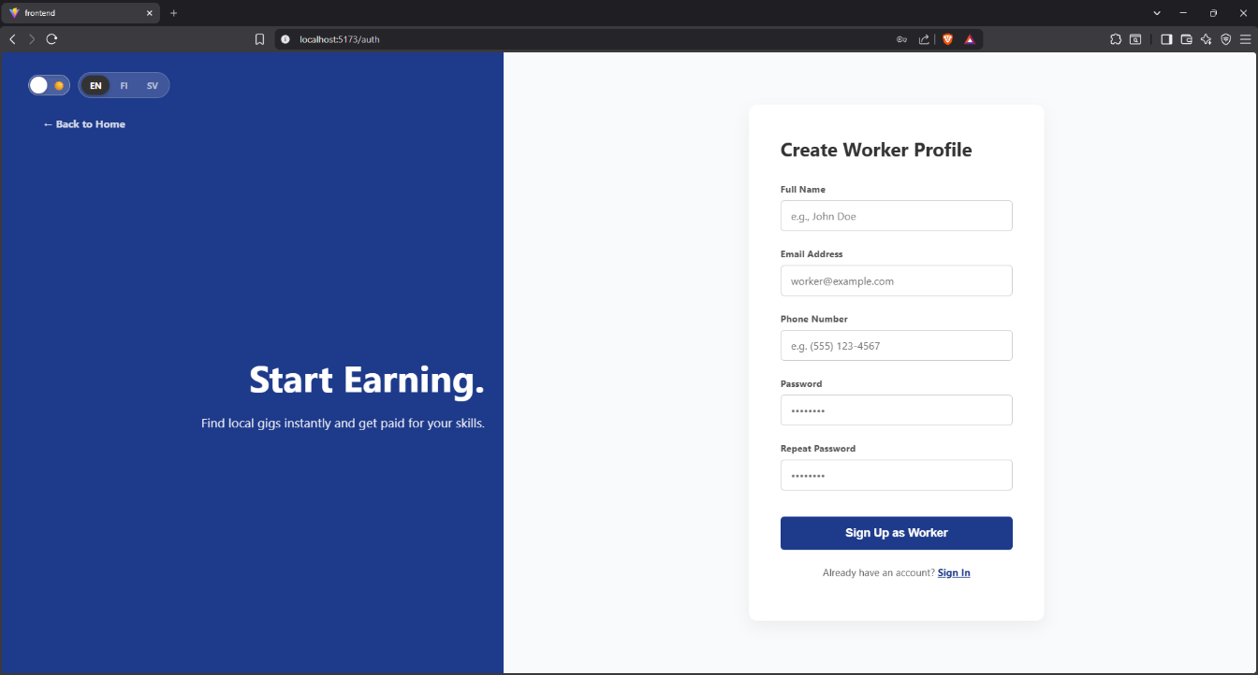
Image 2. Worker sign up page
    - Flow 2. New Employer Onboarding
Step | Action | Description
1 | Landing Page | User arrives at split-screen landing with worker (blue) and employer (orange) options.
2 | Click "Looking to hire" | User self-identifies as an employer via the orange-side CTA.
3 | Auth Page — Sign Up | User reaches the employer-themed signup form.
4 | Submit "Sign Up as Worker" | Account is created and user is authenticated.
5 | Complete their profile | Fill up required information such as contact info, service area, skills etc.
6 | Post a job | User is ready to post gigs with a complete profile.

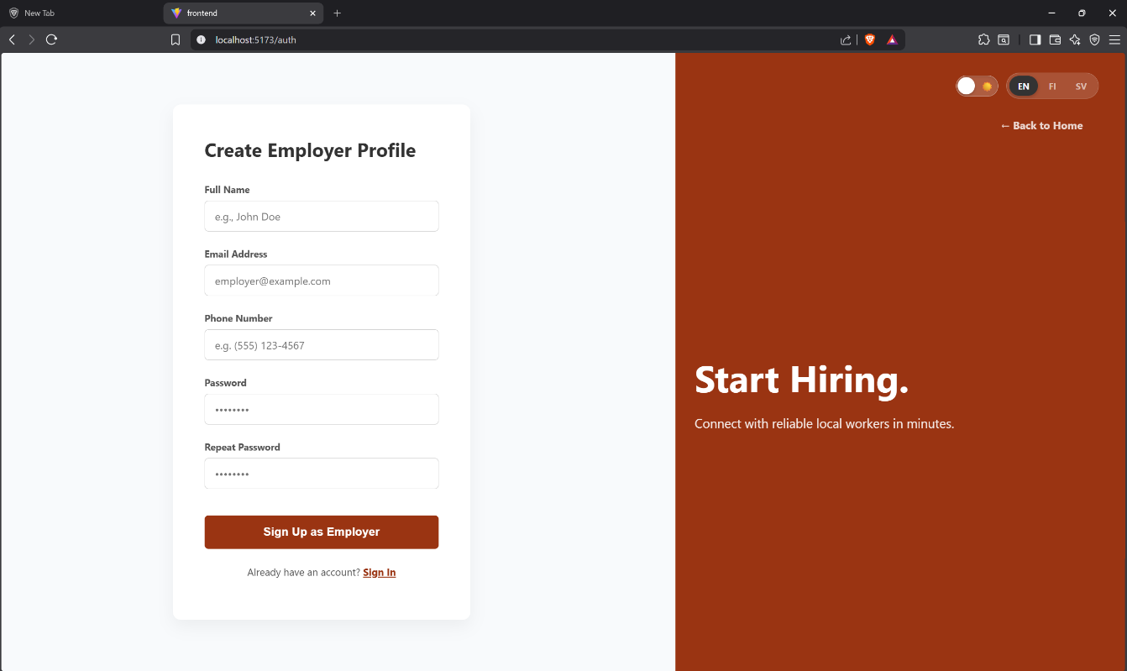
Image 3. Employers sign up page
    - End-to-End Job Lifecycle
This flow maps the full lifecycle of a single gig from initial account creation through to mutual reviews, covering both the employer and worker sides in parallel. It is the platform's core value loop -every other interaction on DingDong supports or stems from this sequence.
Phase 1 — Matching and Bidding
Step | Action | Description
5 | Worker Browses Gigs | Worker scrolls the Available Gigs feed or uses search to find relevant work.
6 | Worker Submits a Bid | Worker opens a job, reviews the brief, and submits a bid stating the price they would do the work for and a short proposal message.
7 | Employer Reviews Bids | Employer sees an aggregated list of incoming bids on their job, with each bidder's profile, rating, hourly rate, and bid amount.
8 | Employer Accepts a Bid | Employer selects the best-suited offer based on price, profile fit, and reviews. The accepted bid notifies the chosen worker; other bidders are informed the role is filled.

Phase 2 — Communication and Work
Step | Action | Description
9 | Conversation Opens | Once a bid is accepted, a Messages thread opens between employer and worker for coordination (timing, location specifics, requirements).
10 | Work in Progress | Worker performs the job offline. The platform's role during this phase is to keep the communication channel open and visible.
11 | Work Marked Complete | Either party marks the job complete; the other confirms.

Phase 3 — Mutual Reviews
Step | Action | Description
12 | Worker Reviews Employer | Worker rates the employer (clarity of brief, fairness, communication) and leaves a short-written review.
13 | Employer Reviews Worker | Employer rates the worker (quality of work, reliability, communication) and leaves a short-written review.
14 | Reviews Published | Both reviews appear on the respective profiles, building reputation that informs future matches and future bid acceptance decisions.

    - Design decisions.
- Added browse jobs as a guest option so user don’t have to go through signing up progress just to see there is no job suited for him or give up before reaching the dashboard
- Removed some information requirements from sign up form that can be setup later at profile settings, which makes creating account easier.

  - Method 4. Cognitive Walkthrough
    - Overview
Cognitive Walkthrough is an expert evaluation method that assesses how easily a new or inexperienced user can learn to perform tasks in a system. Rather than recruiting users, the evaluator simulates a user's thought process step by step, asking at each stage whether the interface supports correct decision-making (Theseus, 2025). At each step, four questions are asked:
- Will the user try to achieve the right outcome?
- Will the user notice that the correct action is available?
- Will the user associate the correct action with the outcome they expect?
- Will the user see progress toward their goal after performing the action?
The walkthrough was applied to the first-time-user task on the platform: a new worker signing up and successfully applying to their first gig. This task was selected because every downstream worker behaviour depends on its successful completion, and because the original signup flow deliberately collected only the minimum information needed to authenticate, leaving important profile fields to be completed afterwards.
Assumptions about the user were defined before walking through the task:
- Goal: "I want to sign up and apply for a gig."
- Prior knowledge: familiar with signup forms but not familiar with DingDong.
- Context: First-time visitor.
Step 1 -- Landing page: identify the worker pathway
Question | Assessment
Will the user try the right outcome? | Yes. The split-screen layout with a clear question ("Looking for a job?") matches the user's intent immediately.
Will they notice the correct action? | Yes. The blue "Find a Job" button is large, centered, and visually dominant on its half of the screen.
Will they associate the action with their goal? | Yes. The button text directly mirrors their intent.
Will they see progress? | Yes. Clicking transitions them to the worker-themed (blue) auth page, reinforcing they are on the right path.
No issues found at this step
Step 2 -- Auth page: complete signup
Question | Assessment
Will the user try the right outcome? | Yes. The "Create Worker Profile" heading confirms they are in the right place.
Will they notice the correct action? | Yes. Five clearly labelled fields (Full Name, Email, Phone, Password, Repeat Password) and a single primary CTA ("Sign Up as Worker") leave no ambiguity.
Will they associate the action with their goal? | Yes. Submitting the form is understood as creating an account.
Will they see progress? | Yes. The user is authenticated and lands on the Available Gigs dashboard.
No issues found at this step
Step 3 -- Dashboard: browse and attempt to apply
Will the user try the right outcome? | Yes. The user opens an available gig and clicks Apply, which is exactly the goal of their visit.
Will they notice the correct action? | Yes. The Apply control is clearly visible on the gig view.
Will they associate the action with their goal? | Yes. The user expects the application to be submitted on click.
Will they see progress? | No. This is where the walkthrough exposed a critical breakdown. Instead of completing the application, the system displayed a "profile missing" error, blocking the action.
    - Issue Identified
First-time workers were able to attempt to apply for gigs before completing their profile and only discovered the requirement at the moment of failure.
    - Design decisions
The post-signup destination was changed. Instead of routing newly registered workers directly to the Available Gigs dashboard, they are now routed straight to the Profile Settings page, where a clear message ("Set up your profile to apply for gigs") tells them exactly what is required and why. This converts a hidden prerequisite into a visible, ordered first step, eliminating the dead-end the original flow produced.
  - Method 5. Accessibility Testing
    - Overview
Accessibility Testing evaluates whether a system can be used by people with diverse physical, cognitive, sensory, and linguistic abilities. Accessibility is not a discretionary feature: it is an ethical obligation, a legal requirement in many jurisdictions including the European Union, and a strong indicator of overall usability. Systems that are accessible to users with impairments tend to be more usable for everyone (Theseus, 2025).
    - Finding A -- Light and dark mode toggle
DingDong includes a light/dark mode toggle accessible from the top-left of every authenticated screen. From an accessibility perspective, this feature addresses several distinct user groups: users with photophobia or migraine sensitivity who cannot tolerate bright interfaces, users in low-light environments where bright backgrounds cause strain, and users with certain visual processing differences who find dark-on-light or light-on-dark text easier to read.
Outcome: The audit confirmed that the toggle was a meaningful accessibility feature rather than a cosmetic one. The toggle was retained as a permanent part of the navigation layout.
    - Finding B -- Multilingual support (English, Finnish, Swedish)
DingDong supports three languages: English (EN), Finnish (FI), and Swedish (SV). The language switcher is located adjacent to the theme toggle. This feature is particularly significant in the Finnish context: Finnish and Swedish are both official national languages, and a meaningful share of the target user base, particularly older small business owners and recent immigrants may have limited comfort with English.
Outcome: The audit confirmed that all primary user-facing strings (headlines, navigation labels, form fields, button text, empty-state messages) had been translated. The switcher was kept in a consistent position across all screens to ensure that users who change language once on the landing page continue to see the chosen language throughout their session.
    - Design decisions
- Retained the light/dark mode toggle as a permanent navigation element.
- Retained trilingual EN/FI/SV support and standardized the placement of the language switcher across all screens.
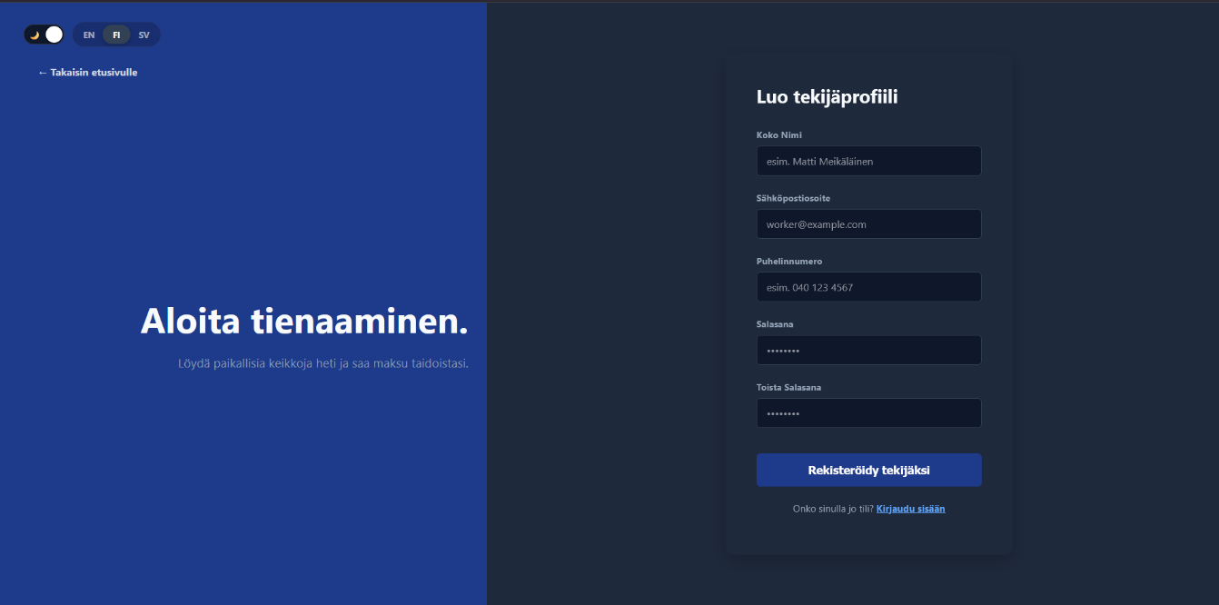
Image 4. Dark mode and Language change demonstration
- Conclusion
Working through these five methods showed us that good UI/UX design isn't really about following a fixed checklist, it's about checking your assumptions before users have to. The Comparative Analysis confirmed that DingDong's dual-role idea was solid, the Moodboard kept the visual decisions consistent, the User Flows revealed gaps the screen designs alone couldn't show, the Cognitive Walkthrough caught the profile-completion blocker before it became a real user complaint, and Accessibility Testing made sure the platform actually works for the people it's meant for.

